Computer Vision Homework 8

Name: 黃新予

Student ID: f08922136

1. gaussian noise (amplitude = 10), SNR = 13.60264  
   

|  |  |
| --- | --- |
|  |  |
| 3x3 box filter, SNR = 17.760831538293285 | 5x5 box filter, SNR =14.868753667252186 |
|  |  |
| 3x3 median filter, SNR =17.65 | 5x5 median filter, SNR =15.99 |
|  |  |
| Opening then closing, SNR =13.2366 | Closing then opening, SNR =13.57988 |

1. gaussian noise (amplitude = 30), SNR =4.192209704065997  
   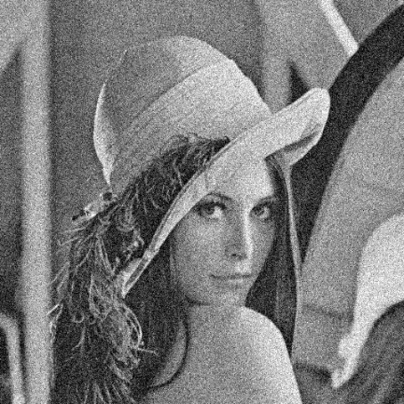

|  |  |
| --- | --- |
|  |  |
| 3x3 box filter, SNR = 12.625380397407307 | 5x5 box filter, SNR =13.333337431692193 |
|  |  |
| 3x3 median filter, SNR =11.096 | 5x5 median filter, SNR =12.91 |
|  |  |
| Opening then closing, SNR =11.1949 | Closing then opening, SNR =11.215797 |

1. salt and pepper (threshold = 0.1), SNR = -1.8586218753812984  
   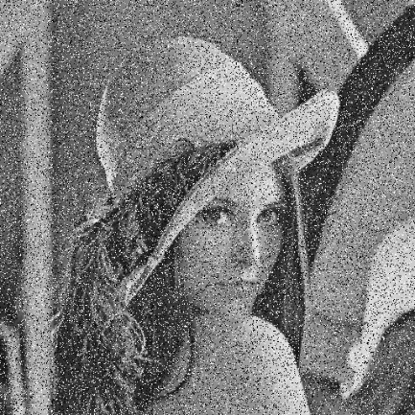

|  |  |
| --- | --- |
|  |  |
| 3x3 box filter, SNR = 6.637403825387397 | 5x5 box filter, SNR =8.811223153311404 |
|  |  |
| 3x3 median filter, SNR =15.61 | 5x5 median filter, SNR =15.78 |
|  |  |
| Opening then closing, SNR = -2.135329 | Closing then opening, SNR =-1.83237 |

1. salt and pepper (threshold = 0.05), SNR = 1.04132386403326  
   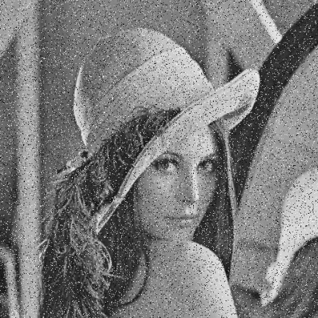

|  |  |
| --- | --- |
|  |  |
| 3x3 box filter, SNR = 9.625627981424241 | 5x5 box filter, SNR =11.274493647011665 |
|  |  |
| 3x3 median filter, SNR =19.44 | 5x5 median filter, SNR =16.36 |
|  |  |
| Opening then closing, SNR =5.6556 | Closing then opening, SNR =6.034335 |